Great Britain. Symbols. Traditions
- Заполни таблицу
Country | Floral symbol | Number of flag | Capital
England | … | … | …
… | … | … | …
… | … | … | …
… | … | … | …
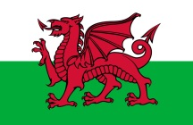
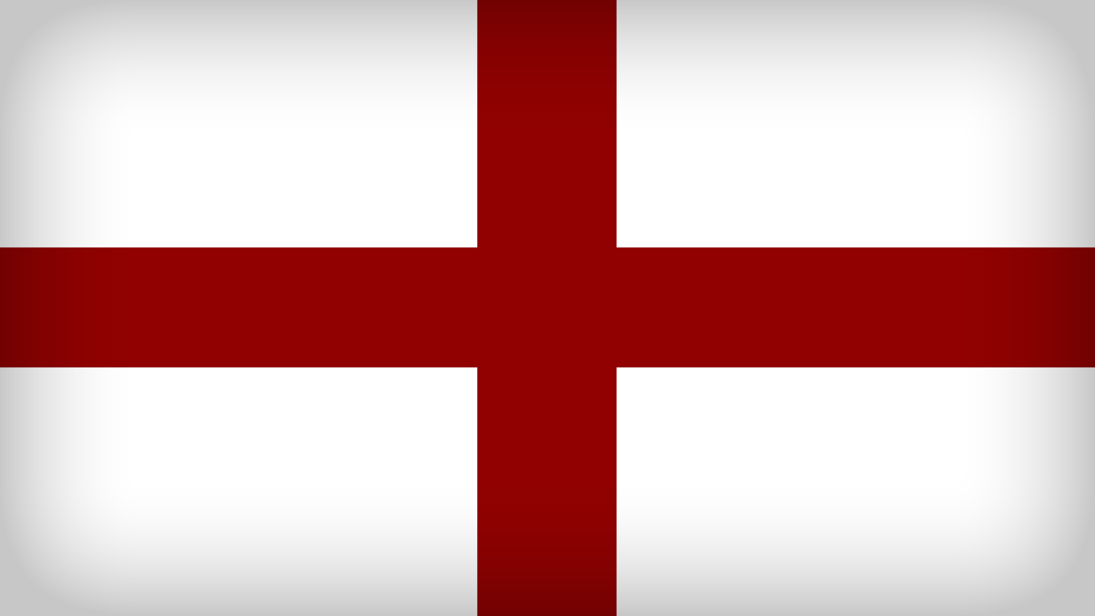
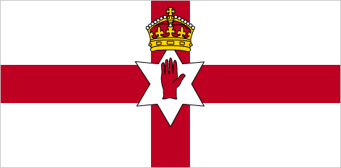
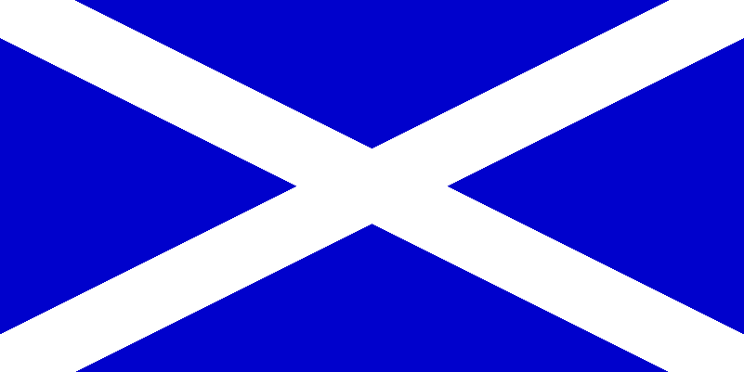

1 2 3 4
- Ответь на вопросы.
- How many countries does the UK consist of? Name them.

- What is the capital of the UK?
- What is the capital of Wales?
- What is the capital of Scotland?
- What is the capital Northern Ireland?
- What is the capital of England?
- What is the full (полное) name of the UK?
- What is the official language of the UK?
- What is the name of English flag?

- Дополни предложения
- The biggest part of Great Britain is … .
- The capital of England is … .
- The English National Day is on … .
- … people live in England.
- The English educational centres are … and … .
- Big cities of England are … .
- The longest river of England is … .

- Найди 10 слов по теме «Великобритания»
h | c | q | w | a | l | e | s | i | o | p | z | m | x | c
m | l | w | h | h | k | n | d | b | e | l | f | a | s | t
c | o | f | k | u | l | g | f | u | d | r | d | n | b | v
s | v | d | l | q | w | l | g | y | s | t | a | c | n | l
i | e | s | p | t | h | a | m | e | s | h | f | h | m | o
o | r | h | c | e | z | n | f | g | b | g | f | e | j | n
c | a | m | b | r | i | d | g | e | p | f | o | s | h | d
p | o | l | s | y | u | e | d | f | i | s | d | t | g | o
x | t | h | i | s | t | l | e | h | l | k | i | e | f | n
q | y | i | t | b | n | c | v | f | t | y | l | r | u | p

